**EduTutor AI: Personalized Learning with Generative AI and LMS Integration**

**1. Project Title**

EduTutor AI: Personalized Learning with Generative AI and LMS Integration

**Team Members:**

* Mohammed Azad S
* Mohammed Saifullah K
* Mohammed Zubair A

**2. Introduction**

**Purpose:**  
EduTutor-AI is designed to enhance the learning experience of students by providing AI-powered explanations of complex concepts and generating quizzes for self-assessment. The system leverages IBM Granite LLM with Gradio to deliver a user-friendly, interactive educational platform.

**Features:**

* **Concept Explanation**: Provides detailed explanations of academic topics with real-world examples.
* **Quiz Generator**: Creates quizzes with mixed question types and answers for practice.
* **Conversational Interface**: Natural language interaction between students and AI.
* **Interactive UI**: Intuitive Gradio-based interface with tabs for different modules.
* **Custom Styling**: A visually engaging experience with gradient backgrounds and modern UI design.

**3. Architecture**

**Frontend (Gradio):**

* Built using Gradio Blocks for interactivity.
* Provides tabs for “Concept Explanation” and “Quiz Generator.”
* Implements custom CSS for a modern, student-friendly look.

**Backend (Transformers + PyTorch):**

* Uses Hugging Face’s transformers library to load IBM Granite LLM.
* Responsible for text generation (explanations, quizzes).
* Utilizes PyTorch for GPU acceleration where available.

**Model Integration (IBM Granite LLM):**

* Model used: ibm-granite/granite-3.2-2b-instruct.
* Provides natural language understanding and generation.
* Handles prompt engineering to generate detailed, contextual responses.

**4. Setup Instructions**

**Prerequisites:**

* Python 3.9 or later
* pip and virtual environment tools
* Internet connection (to download model and run app)

**Installation Process:**

1. Clone the project repository.
2. Install dependencies:
3. pip install transformers torch gradio
4. Run the script:
5. python EduTutor-AI.py
6. Access the Gradio interface through the local or shared link.

**5. Folder Structure**

EduTutor-AI/

│── EduTutor-AI.ipynb # Main notebook script

│── requirements.txt # Dependencies

│── /assets # (Optional) Screenshots or UI assets

**6. Running the Application**

* Launch the script (python EduTutor-AI.py).
* Open the Gradio app in your browser.
* Navigate between tabs:
  + **Concept Explanation** → Enter a concept and get a detailed explanation.
  + **Quiz Generator** → Enter a topic and receive a quiz with answers.
* Responses are generated in real time using IBM Granite LLM.

**7. API Documentation**

(Currently, the project does not expose separate APIs — interaction is done via Gradio UI. Future versions may include REST API endpoints for integration with LMS platforms.)

**8. User Interface**

* **Tabs**:
  + Concept Explanation
  + Quiz Generator
* **Styling**: Gradient background (black to green), glowing buttons, modern text boxes.
* **Footer**: “Powered by IBM Granite LLM & Gradio.”
* **Interactive Outputs**: Explanations and quizzes displayed in styled textboxes.

**9. Testing**

* **Unit Testing**: Validated prompt generation and model outputs.
* **Manual Testing**: Checked user input edge cases (empty input, long prompts).
* **UI Testing**: Verified that tabs, buttons, and outputs render correctly in Gradio.
* **Performance Testing**: Ensured responses are generated within reasonable time on both CPU and GPU.

**10. Known Issues**

* Requires internet connection to download IBM Granite model initially.
* Performance may be slow on CPU-only machines.
* Limited to two main features (explanations + quizzes) in current version.
* No user authentication or history tracking yet.

**11. Screenshot**

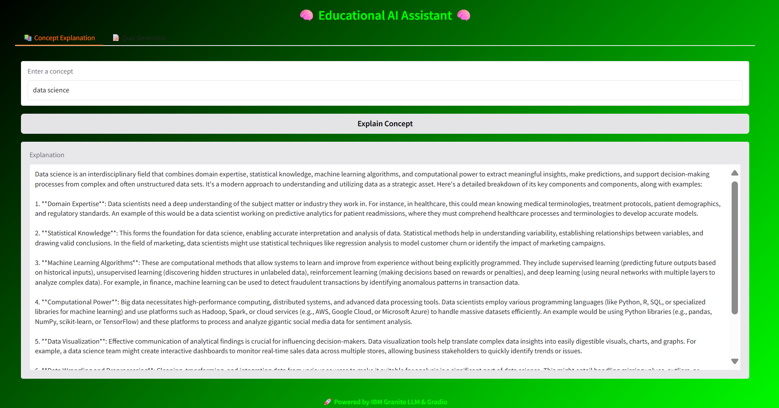

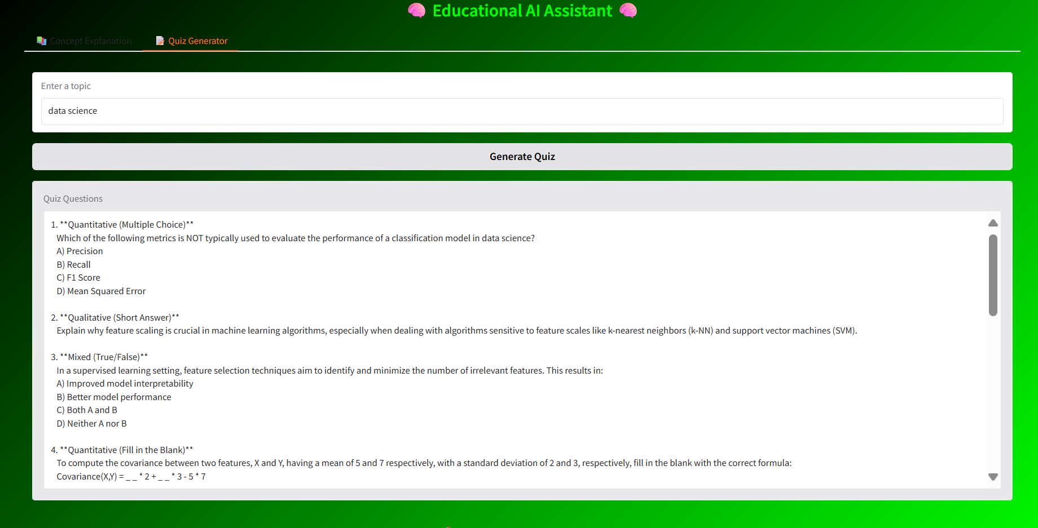

**11. Future Enhancements**

* Add support for **voice-based interaction**.
* Enable **REST API endpoints** for LMS integration.
* Expand **quiz customization** (difficulty levels, MCQs, fill-in-the-blanks, etc.).
* Store **user learning history** for personalized recommendations.
* Include **multilingual support** for global learners.
* Deploy on **cloud platforms** (AWS, IBM Cloud, etc.) for scalability.

**13. Conclusion**

EduTutor-AI demonstrates the potential of combining large language models with intuitive user interfaces to transform the way students learn and practice. By offering detailed explanations of complex concepts and generating interactive quizzes, the system enhances self-paced learning and promotes better understanding. With its simple architecture, scalable backend, and user-friendly Gradio interface, EduTutor-AI serves as a foundation for building smarter educational tools.

Although the current version focuses on concept explanation and quiz generation, future enhancements such as voice interaction, multilingual support, and integration with learning management systems will further expand its capabilities. Ultimately, EduTutor-AI aims to empower learners with personalized, accessible, and intelligent educational assistance.